NextField EOL to NextField Infographic
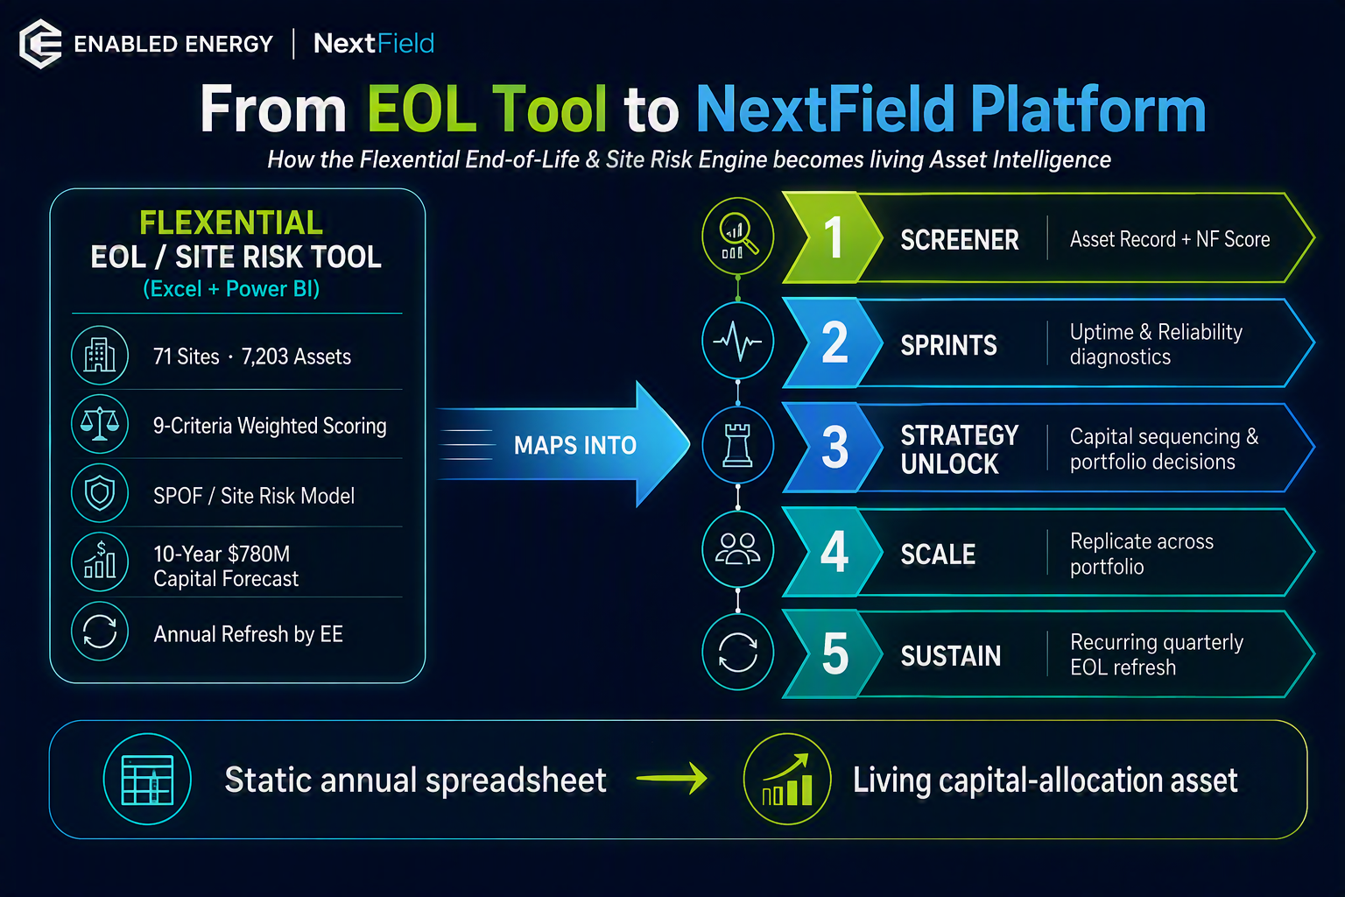 I'll create a professional infographic mapping the Flexential EOL / Site Risk Tool into the NextField Platform, using EE's branding style (dark navy, green, and blue palette) and a clean executive layout suitable for Thursday's NF call.Here's the infographic mapping the Flexential EOL / Site Risk Tool into the NextField Platform, built in EE's brand style for Thursday's NF call.
It captures the core narrative in one view:
- Left: the EOL tool as it exists today — 71 sites, 7,203 assets, 9-criteria scoring, SPOF/site-risk model, the $780M 10-year forecast, and the annual EE refresh.
- Right: how each capability lands in NextField's five layers — Screener, Sprints, Strategy Unlock, Scale, and Sustain.
- Bottom: the strategic upgrade — a static annual spreadsheet becoming a living capital-allocation asset.
Want me to drop this into a PowerPoint slide (with speaker notes for the Leo/Joe conversation), or produce a companion one-pager that adds the delivery-model and Sustain revenue angle beneath the mapping?

